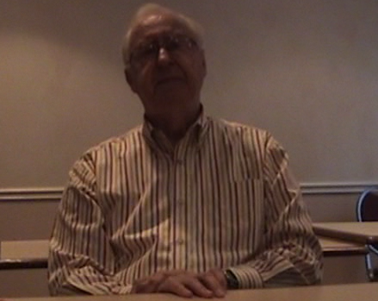
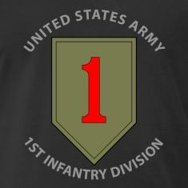
RICHARD “DICK” BIEHL
1st DIVISION SOLDIER
&
D-DAY VETERAN

FIRST STOP AFRICA
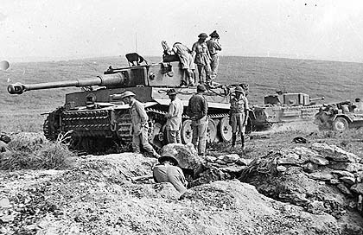
“I was sent as a replacement for the battle that just ended in Africa, the ship zig-zagged in the water and one week later I was in Morroco. Casablanca was a beautiful city I was taken to a tent camp and I went through training in the mornings due to the mid day heat I had early morning rises at 4:00am. I went to the harbor to where trucks were to be driven over with replacement soldiers and we traveled for a week over north coast of Africa when we got to Tunisia we started to see the evidence of the war. We saw Italian POW's who wanted our Cigarettes, we heard that Sicily was just Invaded they issued us Masquito netting and sunglasses. I remember that Bazerdi was a huge cache for German weapons from the Afrika Korps.”

SICILIAN CAMPAGIN
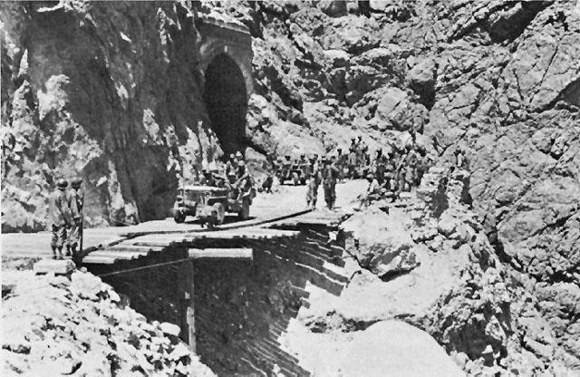
“A couple of days later I was placed on ACT's and we went to Sicily. The Invasion had taken a few days before and I was told to stay on the beach and that we would be collected by a unit. The 1st infantry had suffered some heavy losses soon I could hear artillery fire from both allies and Axis. I was assigned to the 1st squad and I was the first scout, I carried a Springfield rifle. I arrived at the front, the units boardering the left was the British 8th army and on the right was several divisions of the US army. we arrived clsoe to Mt. Etna. Sicily was very hot and dry and at night it was cold in the mountains As a scout, you have the feeling the whole world is watching you The final moments were outside troiena the Germans and Italians were not willing to give up their position Liberating the Island took about 45 days. We were given replacement equiptment and we were told we would be leaving the Island. The Third army division was sent to Invade Italy. We were told to pack up and that we would be leaving the island for an unknown destination. We went to Siracusa and the boarded a British troop ship, We were told they were going to England.”

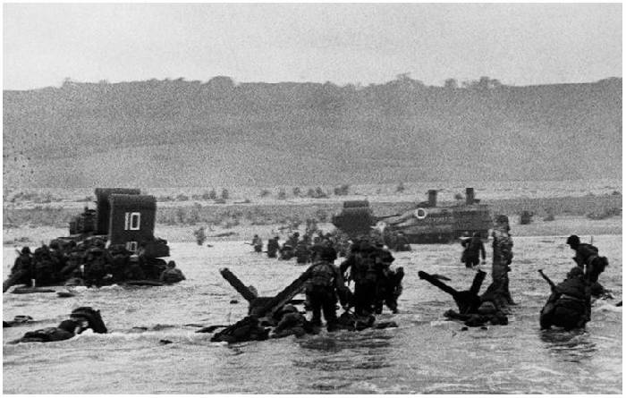
INVASION OF NORMANDY
“We set sail June 5th and we went to Omaha Beach, the first view of the beach was 2 miles out I saw smoke, flames, heard horrible noises. My boat was on a sand bar stuck, the officers told the company commander they had to disembark. I was the first off on the Port side there was water up to my chest, the artillery fire was hitting the water and soon the medics were approaching the vessels with wounded. The wounded men were placed in landing craft to return to engalnd. I arrived on the beach and there was chaos there was Landing craft on fire, there were broken weapons, personal items, two tanks which were disabled, small arms fire had been silenced however sniper and artillery fire was high. We suffered 8-9 casualties from mines and shrapnal, One of the men in the division walked into a mine field he was lying in the mine field he had to wait for engineers to get him out. We waited at the bluff until their commander could find company HQ. The Artillery and mortar fire almost hit us on the bluff, we saw the bodies floating in the water and utter destruction. We stayed their for some time then we moved out. We were very exhausted at this time, then we were given the objective to take another town. On the beach there were 85 Pillboxes, 85 machine gun posts, 19 artillery posts belonging to the Germans.”

WAR MEMORIAL
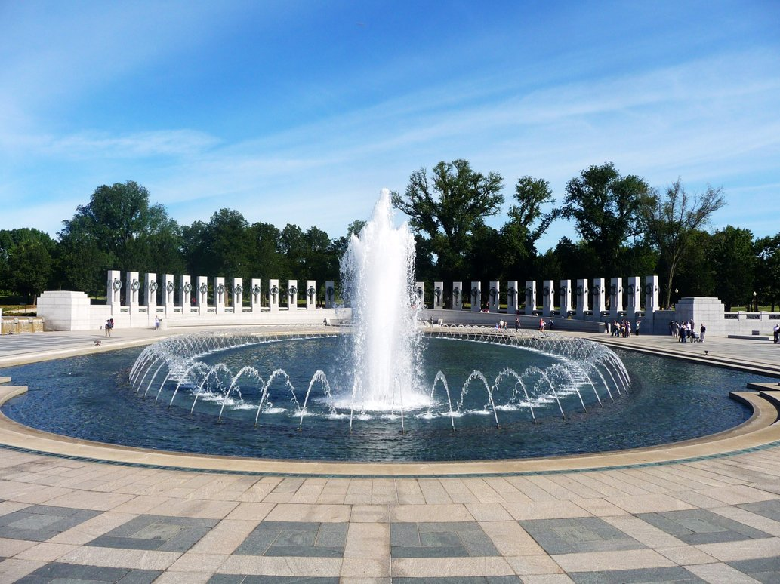
“It's well done the location is the best that could be found its meaningful, covers just about every aspect of WW2. TV programs are meaningful until they are too hollywood sometimes the factual aspects are cast aside. I was a grand Marshal of Memorial day Parade and it was an Honor to part of the community program.”

